The Psychic Game

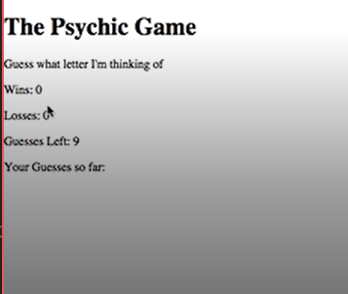

Goal: User has to guess what letter computer is thinking

1. List user options, list computer options
2. User clicks a letter.
   1. userGuess = computerGuess;
      1. user win++
      2. reset guesses left
      3. reset your guesses so far
      4. Alert: You are a psychic
   2. userGuess != computerGuess;
      1. decrease guesses left
      2. guessesSoFar++
      3. Alert: Guess again
   3. when guessesSoFar >10
      1. losses++
      2. Alert: I guess you are not a psychic